**Car hire app**

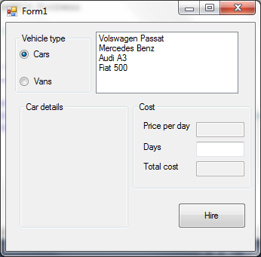

**Class diagrams**

|  |
| --- |
| **Vehicle** |
| * Double price; * Int engineSize; * String make, model, fuelType; * Bool manual, available; * DateTime availableOn; |
| + Setters ang getters for all variables;  + string getName() – “Make Model”  + virtual string getDetails() – “Vehicle description as a formatted string”  + string ToString() – “Make Model”  + virtual string formatLine()– “|make|model|engineSize|manual|price|”  + void rent(int days) |

|  |
| --- |
| **Van : Vehicle** |
| * Double cargoSpace * Bool sideDoor * Char wheelBase |
| + Setters ang getters for all variables;  + string getDetails() – – “Van description as a formatted string”  + virtual string formatLine()– “van|make|model|engineSize|manual|price|  cargoSpace|sideDoor|wheelbase|available|  availableOn” |

|  |
| --- |
| **Car : Vehicle** |
| * Int doors, seats; * String body; |
| + Setters ang getters for all variables;  + string getDetails() – – “Car description as a formatted string”  + virtual string formatLine()– “car|make|model|engineSize|manual|price|  doors|seats|bodyType|available|availableOn” |

|  |
| --- |
| **CarHire** |
| - static List<Car> cars;  - static List<Van> vans;  + static List<Car> availableCars  + static List<Van> availableVans  - static string path; |
| + CarHire(String filepath)  + static void readFile()  + static void writeFile()  + static void updateLists() |

|  |
| --- |
| **FileOperations** |
| - static List<Car> cars  - static List<Van> vans  - static string path |
| + static readFile(String filepath, out List<Car> cars, out List<Van> vans)  + static writeFile() |